1. What is data structure?

A DS is a way of organizing data so that it can be used effectively.

1. Abstract data type

An ADT is an abstraction of a data structure which provides only the interface to which a data structure must adhere to. Interface does not give any specific details about how something should be implemented or what programming language. Example: list, queue, map, vehicle

1. Array

Contiguous area of memory consisting of equal size elements indexed by contiguous integers. Special case with array is, they can have constant time access. The formula to find address of any element is

Array_address + element_size x ( i – first_index )

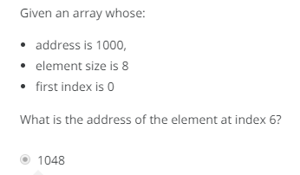

For multi-dimensional formula it would be

Array_address + (element_size x ( irow – first_index )) + (icol – first_index)

Times for common operations

|  |  |  |
| --- | --- | --- |
|  | **Add** | **Remove** |
| **Beginning** | O(n) | O(n) |
| **End** | O(1) | O(1) |
| **Middle** | O(n) | O(n) |